Nathan, first of all, I am not sure which version of the Component Diagram you are trying to work off of, but here is a copy of information in the version you should be working from:

Figure 1.2 & 1.3 — Web Client and Mobile Client Shared Architecture
The Web Client and Mobile Client share the same internal architecture and corresponding subcomponents. Therefore, the shared subcomponents are labeled with both their Web Client (1.2.x) and Mobile Client (1.3.x) numbering references.

Differences between the Web Client and Mobile Client are primarily related to layout and presentation. The Web Client uses a desktop layout with sidebar navigation, while the Mobile Client uses a mobile layout with hamburger navigation and responsive screens.
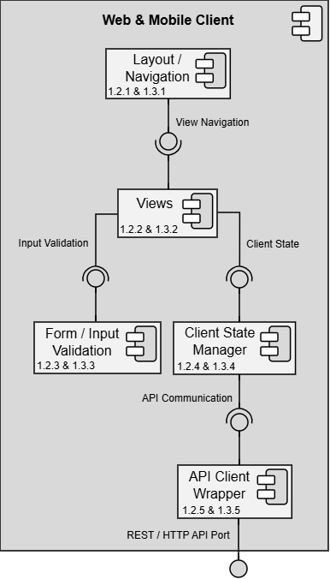

Design Information – Web & Mobile Client
Field | Description / Purpose
View Name & Number | 1.2 – Web Client & 1.3 – Mobile Client
Purpose | Describe the shared client-side architecture used by both the web and mobile interfaces.
Description | The Web Client and Mobile Client share a common internal architecture for presenting views, handling navigation, validating user input, managing client-side state, and communicating with the API Gateway / Orchestrator through the REST/HTTP API Port. Differences between the clients are primarily related to layout and presentation.
Requirements | 1.2.1 Application Scope; 4.2 Modern Web Browser Support; 4.3 Mobile and Computer Browser Support; 4.4 Supported Browsers
Elements | Layout / Navigation
 | Views
 | Form / Input Validation
 | Client State Manager
 | API Client Wrapper
Navigation / References | 1.4 API Gateway / Orchestrator; UI Views 1.1–4.2; REST/HTTP API Port
Viewpoint | Component Diagram

I wondering if the assignment feels bigger than it actually is because the older version of the Web & Mobile Client diagram contained a lot of system functionality. The current diagram is much simpler.

For this assignment, ignore the individual screens, notifications, profile features, search features, resume features, and other application-specific functionality.

Your job is only to document these 5 shared client-side subcomponents:
1.2.1 & 1.3.1 — Layout / Navigation
1.2.2 & 1.3.2 — Views
1.2.3 & 1.3.3 — Form / Input Validation
1.2.4 & 1.3.4 — Client State Manager
1.2.5 & 1.3.5 — API Client Wrapper

Think of each Entity Identification Table as answering this question:
"What entities would exist if I were building only this one subcomponent?"
For example:
Layout / Navigation
- navigateToView()
- currentView
- routePath
- menuItem
- navigationModule
Views
- viewModel
- renderView()
- selectedView
- screenData
- viewController
Form / Input Validation
- validateInput()
- formField
- validationRule
- errorMessage
- inputValidator
Client State Manager
- updateClientState()
- applicationState
- userSession
- selectedFilters
- stateStore
API Client Wrapper
- sendApiRequest()
- apiResponse
- requestPayload
- endpointUrl
- apiClient

You do not need to create perfect entities. The goal is simply to identify the major classes, functions, variables, modules, and data used by each subcomponent.

A good approach would be:
- Open a blank Word document.
- Create the Layout / Navigation EIT.
- Brainstorm 10–15 entities that belong to Layout / Navigation.
- Repeat for the remaining four subcomponents.

Don't think about the whole system. Focus on one box in the diagram at a time. I hope this helps and if you are still struggling please reach out and I will do what I can to help out. You got this!

